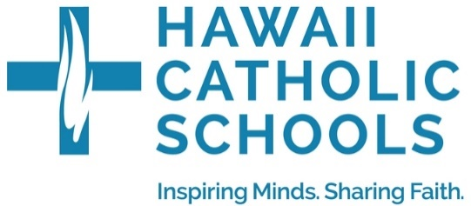

2025 Hawaii Catholic Schools “200 Year of Catholicism in Hawaii”
Logo Contest

THEME: “Mission of Aloha ”
Designs will be evaluated based on the following:
- Relevance to Theme
  - Reflects the spirit of Aloha, Catholic faith, and Hawaiian culture
  - Honors the history and mission of Catholicism in Hawai‘i
- Originality & Creativity
  - Original work created by the entrant (no AI-generated or copied artwork)
  - Artistic expression is encouraged
- Simplicity & Versatility
  - Clean and scalable for various uses (digital, print, shirts, etc.)
  - Looks good in both color and black & white
- Incorporation of Elements (Optional but encouraged)
  - Catholic symbols (e.g., cross, Bible, Holy Spirit, rosary, church architecture)
  - Hawaiian cultural symbols (e.g., plumeria, taro leaf, canoe, islands, ocean, lei)
- Technical Specifications
  - Format: JPEG or PNG (high resolution, at least 300 DPI)
  - If chosen as a finalist, the original editable design file may be requested (e.g., PSD, AI, or vector format)
ART GUIDELINES:
- Logo reflects Mission of Aloha, Catholic faith, and Hawaiian Culture
- Original art, creative, and versatile
- Effective in black and white
- Submit as a JPED or PNG (300 DPI)
- No AI-generated or copied art
- No Lettering - your art carries the message
- Submissions at the Diocesan Level will be scored on application and interpretation of the theme, neatness, presentation, creativity and effort.

GENERAL RULES:
- Contestants may enter only once. Entries not conforming to the rules will be disqualified.
- All contest submissions becomes the property of the Diocese of Honolulu and Hawaii Catholic School Department with the right to display/and or publish any or all material.
- Decisions of the judges will be final. Judges reserve the right to make no award in a Division.
- Each entry sent to the diocesan level, must be accompanied by a 2025 Entry Form properly signed and completed. Names must be legible. Forms must be taped to back of entry.
- Plagiarism is grounds for disqualification from contest. Commercial entries will be disqualified.
- Awards will be provided to Diocesan 1st, 2nd and 3rd place in each of four levels (K-2, 3-5; 6-8; 9-12)
- Parish/Schools will conduct their own local contest and forward their top winner in each division to the Hawaii Catholic Schools Office
  - Parish/Schools are encouraged to celebrate at the local level with prizes and displaying of student work.
- Parish/Schools are encouraged to gain support from parents or local businesses for local prizes
- Parishes/Schools are encouraged to post local and diocesan winners on their website
- Prizes consist of: 1st Place = $200.00, 2nd Place = $100.00, 3rd Place = $50.00

TIMELINE:
- September – students learn about Mission of Aloha and create pieces of art; Parish/Schools can invite Fr. Lane, Fr. Herman, or Deacon Keith to speak to your students about this celebration at this time, school chooses diocesan submissions.
- November 6, 2025, 5pm – deadline for schools to submit to Hawaii Catholic School office.
- November 10-21, 2025 – judging at Diocesan Level
- December 5, 2025– winners announced

